Request for Qualification (RFQ): Seattle Preschool Program

School Year 2023-24

REQUEST FOR QUALIFICATION TIMELINE

EVENT | DATE/LOCATION*
Phase 1: Request for Qualification*
Request for Qualifications (RFQ) Application Opens | December 7, 2022
Live RFQ Information Session (will be recorded) | 5PM, Thursday, December 15, 2022
Deadline for Questions | 5PM, Wednesday, January 11, 2023
Request for Qualification (RFQ) Application Due | 5PM, Wednesday, January 18, 2023
Phase 2: Evaluation*
Applications Review and Interviews | January 19 – March 7, 2023
Notifications issued to applicants | March 2023
Anticipated start of contract coordination | March 1, 2023
Contract Start Date | July 1, 2023
*Dates are subject to change; Exact dates/times for RFQ information sessions to be listed on DEEL’s website: http://www.seattle.gov/education/for-providers/funding-opportunities

INTRODUCTION
The Department of Education and Early Learning (DEEL) is notifying organizations, early learning providers, and any other entities providing services described in this Request for Qualification of a funding opportunity through the City of Seattle 2018 Families, Education, Preschool and Promise (FEPP) Levy. The FEPP Levy aims to achieve educational equity, close opportunity gaps, and build a better economic future for Seattle students.

The Seattle Preschool Program (SPP) launched in the 2015-16 school year with the goal of providing accessible, high-quality preschool services for Seattle children designed to improve their readiness for school and to support their subsequent academic achievement. The first four years of SPP were designed to be a demonstration phase, wherein the City would establish sustainable practices to achieve its goal of eliminating race-based disproportionalities in kindergarten readiness.

Purpose
The purpose of the Seattle Preschool Program RFQ is to solicit applications to identify qualified early learning providers in Seattle of the opportunity to join the SPP, funded by the FEPP Levy.

DEEL has up to two million dollars available to contract for approximately six new SPP classrooms for the 2023-24 school year. These new classrooms will include a combination of classrooms identified through this RFQ, expansion of existing SPP providers, and direct contracting with eligible entities. This RFQ is intended for center-based programs and only for new agencies not currently contracted with the Seattle Preschool Program. [Existing SPP providers will be given separate instructions for applying through a different process.] Family Child Care (FCC) programs participate in SPP through a separate FCC-HUB model.

Contracting is expected to begin in July 2023 with preschool classes to start in September 2023. To be considered for funding, eligible applicants are invited to submit an RFQ application by January 18, 2023. DEEL reserves the right to re-release this RFQ throughout the FEPP Levy period for subsequent school years.

Overview of RFQ process
There are two steps to becoming an SPP provider that are further outlined below under the RFQ Roster Design section.
STEP ONE:
First, applicants must submit an RFQ application to demonstrate how they meet the qualifications for becoming an SPP provider. Successful applicants will be placed on an SPP Roster to be considered for selection as a provider for the 2023-24 school year. If DEEL determines no provider fulfills criteria set out in this RFQ, DEEL may at any time cancel the RFQ without selecting any provider.
STEP TWO:
Second, DEEL will select one or more providers from the SPP Roster according to the criteria outlined in the RFQ Roster Design section. This process will identify the specific classrooms to be awarded funding. This step includes the entire RFQ roster, which incorporates new applicants through this RFQ process as well as considers expansion requests from existing SPP providers and direct contractors. If DEEL determines no provider fulfills criteria set out in this RFQ, DEEL may at any time cancel the RFQ without selecting any provider.

There is no guarantee of work or funding associated with this RFQ opportunity.

INVESTMENT GOALS AND OVERVIEW

Seattle Preschool Program
All FEPP investments across the preschool to post-secondary educational continuum contribute to at least one of three core strategies that support the overarching FEPP Levy goal: 1) Equitable Educational Opportunities 2) High-Quality Learning Environments 3) Students and Family Supports.

The overarching goal of FEPP investments in Early Learning is that Seattle students have access to and utilize high-quality early learning services that promote success in kindergarten. To accomplish this, DEEL:
- Supports preschool providers to offer learning environments that are evidence-based, high-quality, culturally responsive, and equitable;
- Provides families with multiple ways to access high-quality early learning services; and
- Focuses on strategies that will contribute to closing race-based opportunity gaps.

High-quality preschool has been shown to have positive impacts on children’s social and emotional development, health, pre-academic skill development, and executive function skills. FEPP’s SPP investments fund:
- Preschool Services. Preschool providers are eligible to receive funds to deliver preschool services.
  - The City intends to expand the number of preschool slots each program year, to the extent qualified preschool providers are available and able to provide additional slots, with a goal to serve approximately 2,500 children by the 2025-26 school year.
  - There are three types of preschool providers in SPP: (1) Seattle Public Schools (the District), (2) community-based organizations (CBOs), and (3) licensed family child care providers (FCCs), who contract with DEEL through administrative Hubs.
- Tuition Assistance. Families of eligible children will have access to tuition assistance for SPP, subject to program needs and funding availability.
  - Eligible families with household income up to 94% of state median income may participate in SPP free of charge. In 2022, 94% is $100,000 for a family of four.
  - There is a sliding scale for tuition for families above 94% of state median income (see Appendix B).

SPP is designed to benefit:
- Children, by providing access to high-quality preschool to prepare them for their transition to kindergarten. Investments will serve Seattle children who are at least 3 years old by August 31 and not yet eligible for kindergarten in Seattle Public Schools.
- Families, by improving affordability. Providing tuition assistance reduces the financial burden of working families whose children attend high-quality preschool.
- Seattle Public Schools and the community, by reducing the long-term costs for remediation and special education. Studies have found that investing in high-quality preschool leads to reduced costs in health and criminal justice system expenditures and a 10% reduction in third-grade special education placements.

Scope of Work
Early learning providers responding to this RFQ need to meet SPP programmatic and participation requirements as reflected below. DEEL has structures and resources in place to support providers to meet requirements, if necessary, including participation in the Pathway to SPP. More detailed descriptions on program participation are found in the Appendices.

Program Requirements
Classroom size | 20 or fewer children per classroom
Teacher to student ratio | Maximum 1 teacher per 10 students (1:10)
Service hours | 6 hours per day, 180 days per year
Curriculum | Creative Curriculum or HighScope  Waivers may be granted for other high-quality evidence-based curriculum for agencies with EA ratings of Level 4 or higher who have intensive plans for instructional support.
Child-Level Assessments | Teaching Strategies GOLD, ASQ:SE2, ASQ-3, Health Screenings
Classroom Teacher Requirements | Each classroom must at a minimum have 1 lead teacher and 1 assistant teacher, or a two co-lead teacher structure
Required Teacher Qualifications | Lead Teacher:*  Bachelor’s degree (BA) in Early Childhood Education or bachelor’s with 30 ECE credits  Assistant Teacher:*  Associate’s degree in Early Childhood Education or other associate’s degree with 20 ECE credits  *Education degree and ECE credits in ECE must be verified as “approved” in MERIT. Teachers who do not meet these requirements will have up to four years to meet them. College tuition assistance may be available through DEEL.
Site Director | Must meet lead teacher qualifications.
Required Family Support Worker Qualifications (if funded through the SPP Contract) | Associate or higher degree with the equivalent of 30 college quarter credits in related (human services/social work) as “approved” in MERIT.
Family Support | SPP providers are required to provide direct support to the families served at the agency to improve child outcomes.

Provider Participation Requirements
Coaching | SPP providers are required to participate in DEEL-provided instructional coaching that supports directors and teachers in the classroom.
Professional Development | SPP providers are required to participate in DEEL-provided professional development and training in Curriculum, Assessments, and Best Practices.  A schedule of PD opportunities and required trainings will be provided at the start of the contract year. Funding for teacher release time will be available from DEEL.
Directors’ Meetings | Site Directors are expected to attend and actively engage in monthly meetings and/or professional learning communities.
Evaluation | DEEL contracts with a third-party evaluator to measure programmatic growth and child-level outcomes over time. All SPP program are required to participate in this on-going evaluation.
Other Contractual Requirements | SPP contracts are issued yearly and are subject to modifications each year. Contracts will include more specific requirements including, but not limited to data collection and submission, screenings and assessments, attendance, etc.

RFQ ROSTER DESIGN

PLEASE NOTE: There is no guarantee of work or funding associated with this RFQ opportunity.

Successful RFQ applicants will be placed on the DEEL SPP Roster. Inclusion on the roster does not guarantee funding or a contract with the agency but will permit DEEL to select the agency to provide preschool services according to additional criteria listed below. Other key elements of the SPP Roster include:

- No specific contract award has been prescribed. The contract award amount will be based on a mutual determination between the service provider and DEEL in accordance with the slot rates and other funding amounts determined for the school year in which the provider will be providing SPP services. (e.g., the application may list three classrooms, though DEEL may only contract for one classroom.)
- Providers selected from the SPP Roster should plan to enter into contract for the period of July 1, 2023 through June 30, 2024. There may be an opportunity to extend the contract term through summer 2024 to continue SPP services.
- Providers selected from the SPP Roster will be expected to provide preschool classes beginning in September 2023.

Eligibility
DEEL is looking for service agencies and/or individuals who, at a minimum:

1) Are licensed by the Washington State Department of Children, Youth and Families (DCYF) OR exempt from licensing by the State because entity is a public school or institution of higher education

AND

2) Hold a rating of Level 3 or above in the State’s Early Achievers (EA) program OR meet early learning quality standards comparable to EA, as determined by DEEL

SPP Roster Duration
Applicants accepted to the RFQ roster are approved for a two-year period.

Criteria to be selected from the SPP Roster
Once an agency/provider is deemed eligible for the SPP Roster, DEEL will use a prioritization process utilizing the following criteria to prioritize all providers on the roster including existing SPP/Pathway contractors, new applicants and direct contract providers.
The qualified applicant:
- Is in good license standing with all applicable agencies to provide preschool services.
- Is located in a geographical area of high demand (Located in areas of the city with no City-funded preschool or one non-income-restricted classroom that is fully enrolled, demonstrating demand.
(See Appendix D.))
- Serves children historically farthest from educational justice (as determined by Seattle Public Schools’ Equity Tier Index. See Appendix D.)
- Offers additional Services, including, but not limited to:
  - Special education inclusion model
  - Dual Language programming
  - Services to children experiencing homeless children and/or children in foster/kinship care
  - Maintains administrative, financial and organizational controls sufficient to properly use DEEL funds for SPP purposes.
  - Applicants must disclose to DEEL: any past or pending investigations related to Applicant, its preschool services, or activities of its employees and/or officers in connection with their role with Recipient; and any past, pending, or threatened litigation involving Recipient or its employees and/or officers in connection with their role with Recipient.
  - Upon disclosure of any litigation or investigation involving applicant, DEEL reserves the right to disqualify Applicant from consideration. In DEEL’s sole discretion, DEEL may select an otherwise qualified Applicant who is subject to litigation and/or investigation. In that case, any contract will be strictly contingent on Applicant resolving to DEEL’s satisfaction any issues raised by the investigation or litigation that DEEL determines relevant to the SPP program.

This is not meant to be an exhaustive list of criteria. DEEL reserves the right to add criteria as needed to meet the ongoing needs and priorities of the City.

Roster Removal
DEEL reserves the right to remove agencies from the roster of qualified providers. Reasons for removal may include actions or behavior that could be harmful to students, schools, or the community. This includes, but is not limited to, the following actions:
- Inappropriate behavior or language in preschool settings
- Behavior that violates site rules
- Unlawful activities
- Unsatisfactory evaluation
- Agency (including its officers and employees) is subject to investigation and/or litigation without promptly disclosing that investigation and/or litigation to DEEL. If the agency does disclose to DEEL that it is subject to investigation or litigation, DEEL reserves the right to either remove the agency from the Roster or retain the organization. This decision will be made by DEEL in its sole discretion.

EVALUATION CRITERIA

Responses will be evaluated using a three-step process. First, proposals will be reviewed for technical compliance with the requirements of this RFQ. Second, submissions that are technically compliant will be evaluated by a panel of reviewers using criteria outlined in this section. Third, applications will be prioritized based on additional criteria for selection from the SPP Roster. All steps are described in greater detail below.

Initial Screening for Technical Compliance and Evaluating
The checklist below (Table 1) lists the required elements of each proposal. If any of these elements are missing or incomplete, the proposal may not be evaluated further. DEEL reserves the right to waive immaterial defects or irregularities in any submission. Follow-up phone calls may be made to obtain additional information.

Table 1:

Complete | Item | Documentation
Yes No | Submitted on time | N/A
Yes No | Complete packet submitted with complete application | Word or PDF file
Yes No | Licensed by DCYF | Copy of DCYF childcare license
Yes No | Rated in EA a minimum of a 3 or higher | EA Certificate
Yes No | If located in SPS building, documentation of notification to SPS Alignment Coordinator | Documentation of notification which can include email notification, letter, etc.

Application Scoring
Applications to be included on the SPP Roster will be assessed by a review panel. The following criteria in Table 2 will be used when evaluating this RFQ. Applications must score a minimum of 70 points to be placed on the SPP Roster.

The review panel will use written materials provided in the applications as a basis for assessment, but also may elect to conduct interviews or site visits to gather further information or clarify questions.

Table 2:

RFQ Rating Criteria | Points
- Program Experience and Demonstrated Ability  - Clear description of program including mission, vision, and values  - Description of how the program currently meets SPP requirements or a clear plan for how the program intends to meet the SPP requirements  - Demonstrates experience working with 3- and 4-year-old children and their families for 2 or more years  - Demonstrates regular use of child-level assessments and data to support optimal child development and learning  - Demonstrates a strong approach to supporting and engaging families  - Demonstrates the ability to meet the needs of all children (children experiencing homelessness, children with IEPs, etc.) | 40
- Organizational and Administrative Capacity  - Has a proven track record of managing funds with dedicated finance personnel and financial systems in place  - Has adequate organizational staffing to support program  - Demonstrates ability to adequately recruit, hire and retain qualified staff at all levels of the organization | 25
- Cultural Competency and Responsiveness  - Proven track record providing culturally and linguistically relevant services to diverse populations, including dual language programming  - Demonstrates an understanding of cultural competence and describes how it is incorporated into the program and service delivery  - Demonstrates the ability to provide culturally responsive services within diverse communities | 25
- Planning for Challenges  - Applicant acknowledges possible challenges to implementing the program and exhibits forethought and planning to overcome challenges | 10
Maximum points | 100

Selection of specific classrooms
DEEL will use a prioritization process utilizing the following criteria to prioritize all providers on the roster including existing SPP/Pathway contractors, new applicants and direct contract providers.

Table 3:

      - Geography
- Located in areas of the city with no City-funded preschool or one non-income-restricted classroom that is fully enrolled, demonstrating demand.
Demonstrated on the map in Appendix D
      - Additional Services Provided
- Special education inclusion model
- Dual language programming
- Services to children experiencing homelessness and/or children in foster/kinship care
      - Children Furthest from Educational Justice
- Number of children furthest from educational justice being served by or living in the provider’s elementary school attendance zone.
Demonstrated by the Equity Tiers developed by Seattle Public Schools, referenced in the map in Appendix D
This is not meant to be an exhaustive list of criteria. DEEL reserves the right to add criteria as needed to meet the ongoing needs and priorities of the City.

INSTRUCTIONS TO APPLICANTS

Response Guidelines:
The following documents, unless noted otherwise, must be submitted to constitute a complete submission. Incomplete applications will not be scored by the panel.

- Completed application
- Copy of the DCYF License for each site/classroom on the application
- Copy of current Early Achievers Rating
- If located in a Seattle Public Schools building, documentation of notification to SPS Alignment coordinator (shall@seattleschools.org) of application for SPP. (Documentation can include email notification, letter, etc.)

The Application:
Download the application submission document from DEEL’s funding web page, along with any addenda to the application listed there.

Submission:
All applications for the SY23-24 should be submitted electronically. If an applicant cannot submit their application electronically, please contact DEELFunding@seattle.gov by January 16 to plan for a manual delivery.

Complete applications (including all attachments/documentation) must be received on or before 5 PM on January 18, 2023. Applicants should ensure all materials are included in the single submission email.

Email complete applications to: DEELFunding@seattle.gov
- Please use the following naming convention in the subject line of your email and for the electronic files attached:
[Organization Name] – Seattle Preschool Program RFQ
Example: ABC Organization – Seattle Preschool Program RFQ

Questions:
Please direct submission process questions to DEELFunding@seattle.gov and include “Question_ Seattle Preschool Program RFQ” in the subject line.
  - Answers to questions will be posted within five (5) business days in an evolving “Frequently Asked Questions” section in our DEEL Funding Opportunities site. We will post questions and answers to this site for transparency; questions will be kept anonymous. Every applicant will have the opportunity to see all questions being asked and DEEL’s response to those questions.
City Staff are not able to answer questions about this RFQ outside of the question and answer protocol or the information session.

Tips for Success:
- Participate in the informational session or view the recording
- Visit our DEEL Funding Opportunities site for important dates and information regarding required application materials

RFQ APPEAL PROCESS

An agency or individual applying for the Seattle Preschool Program Request for Qualifications (RFQ) has the right to appeal DEEL’s decision on their application.
- DEEL will notify each agency by email of DEEL’s decision on the proposal
- Within four (4) working days from the date of DEEL’s written notification of decision, the agency may submit a written appeal to the Director of DEEL, either in hard copy or via email to DEELFunding@seattle.gov. The basis for the appeal must address one or more of the following criteria:
  - DEEL’s failure to follow the process, evaluation guidelines, or criteria established in the RFQ; or
  - DEEL’s failure to adhere to published criteria and/or procedures.
- The DEEL Director will review the written appeal and may request additional oral or written information from the agency. The DEEL Director will provide a written decision within four (4) working days of the receipt of the appeal, unless the Director notifies the appealing party that more time is required to make an informed decision. The Director’s decision will be final.

APPENDIX A: SPP Additional Requirements

Child Eligibility, Enrollment, and Tuition
Only children who live in City limits are eligible for SPP. Eligible children experiencing homelessness must have a nighttime address within Seattle city limits.
Only children who are 3 or 4 by August 31, 2023 are eligible for SPP.
Agencies may enroll a small number of children who are not eligible for SPP, however the contract amount will be reduced based on this.
SPP has a zero expulsion and suspension policy. No child may be removed from the program for behavior challenges or toilet training.
Families who pay tuition pay DEEL. DEEL then pays the providers on a monthly basis.
Families who also participate in before/after care programs are required to pay fees directly to the provider.
DEEL selects and enrolls children into SPP based on specific prioritization criteria which can be found on the Frequently Asked Questions section of our Seattle Preschool Program parent portal. Applications for the 2023-24 school year open to the public on March 15, 2023.
In certain circumstances, providers may select and enroll eligible children in SPP classrooms, primarily if the contract classroom is blended with ECEAP or Head Start, has rising toddlers who may enroll in the preschool classroom, has dual language programming requirements, or the program has cultural programming requiring specific participants. If a program does not have any of the scenarios above, DEEL will recruit and enroll children into the SPP classroom. (The first year’s enrollment can be a collaborative effort for any already-enrolled children for the upcoming school year.)
Family Support
Providers are required to submit a Family Support Plan for partnering with families and communities to improve child outcomes.
Director Responsibilities and Staffing
Professional Development Plans are required for teachers who do not meet SPP education requirements.
All staff changes must be reported to DEEL.
Directors’ business and professional learning community meetings are held one time per month.
Directors are required to attend a pre-service orientation prior to the school year.
Reporting and Performance
DEEL contracts with external evaluators to assess program performance, both at the classroom and individual child level.
DEEL’s contracts use a performance pay structure. A percentage of the providers’ contracts must be earned by meeting benchmarks.
SPP requires the use of DEEL’s CHIPS database. Providers are required to enter data into CHIPS.
SPP providers are required to track and report attendance.
APPENDIX B: SPP Sliding Scale Tuition
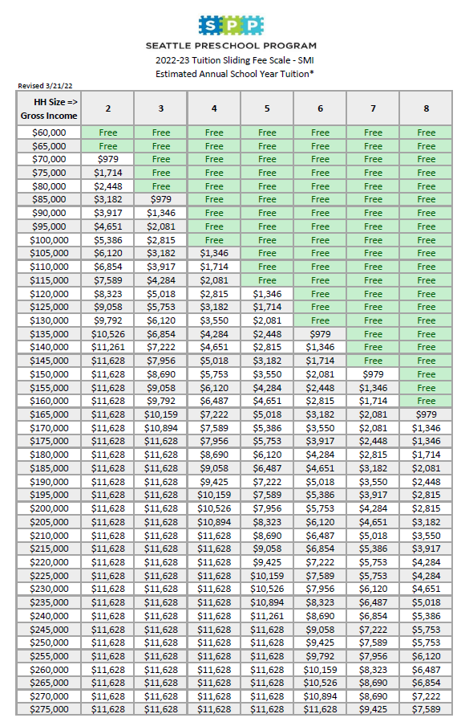

APPENDIX C: 2022-23 SPP Payment Model (subject to change for 2023-24)

2022-23 Provider Payment Rates

Slot Type | Amount Per Slot
Regular Slot¹ | $12,240
Head Start Blended Slot¹ | $6,000
ECEAP Part Day Blended Slot¹ | $6,500
ECEAP School Day Blended Slot¹ | $3,500
ECEAP Working Day Blended Slot¹ | $3,500
Small Class Size Slot Adjustment² | $2,000
1. The Slot Payment ranges between $3,500 and $12,240 per slot, depending on the level of other funding received from ECEAP or Head Start, if any. For blended slots, SPP funds are awarded for the purpose of meeting the additional SPP requirements and activities.
2. The Small Class Size Slot Adjustment is awarded to classrooms whose license capacity is less than or equal to 16. Classroom capacity is based on the provider's license. SPP pays $2,000 for each "virtual" slot beyond the classroom license limit (up to 20 total actual and virtual slots). For example, a classroom with a license limit of 15 is eligible to receive 5 "virtual" slots for a total of $10,000

Classroom Payment Type | Amount if "Meets" | Amount if "Exceeds"
Lead Teacher Pay Enhancement³ | $20,900 | $30,800
SPP Plus Model Adjustment⁴ | $23,000 | N/A
Classroom Funds-Annual Maintenance⁵ | $3,000 | N/A
Classroom Startup Funds-Conversion⁵ | $8,000 | N/A
Classroom Startup Funds-New Classroom⁵ | $20,000 | N/A
COVID Support Funds⁶ (Per Classroom) | $2,500 | N/A
3. The Lead Teacher Pay Enhancement awards providers extra funds for those Lead Teachers who either meet or exceed SPP's education requirements. This amount shall be used to meet SPP's minimum wage requirements (see contract for more detail).
4. The SPP Plus Model Adjustment is awarded to classrooms participating in SPP Plus and have a Special Education contract with Seattle Public Schools for the provision of IDEA Part B services.
5. Each classroom is eligible to receive Classroom Funds - either as an annual maintenance OR a as a startup amount. New classrooms that previously operated as a preschool classroom before joining SPP or Pathway are eligible for the "Conversion" amount. New classrooms that did NOT previously operate as a preschool are eligible for the "New" amount. All others receive maintenance.
6. COVID Support Funds are awarded to each continuing classroom in the amount of $2,500. $5,000 if new.

Classroom Type⁷ | Single-Classroom Providers | Multiple-Classroom Providers
Regular Classroom | $30,000 | $23,000
Blended Classroom | $12,000 | $9,000
7. Family Support Funds are awarded to each classroom; payment is determined by whether a classroom receives ECEAP or Head Start funds. The higher amount in each category is based on whether a provider contracts for a single classroom or multiple classrooms.

Comprehensive Support Payment⁸ | Amount
Base | $320
Tier 1 | $323
Tier 2 | $213
Tier 3 | $122
Tier 4 | $36
8. Comprehensive Support Funds are awarded to each classroom based off the number of slots and tier they are in corresponding to the SPS Equity Tier list.
APPENDIX D: Maps
Geographic areas of need for City-funded preschool by elementary school zone
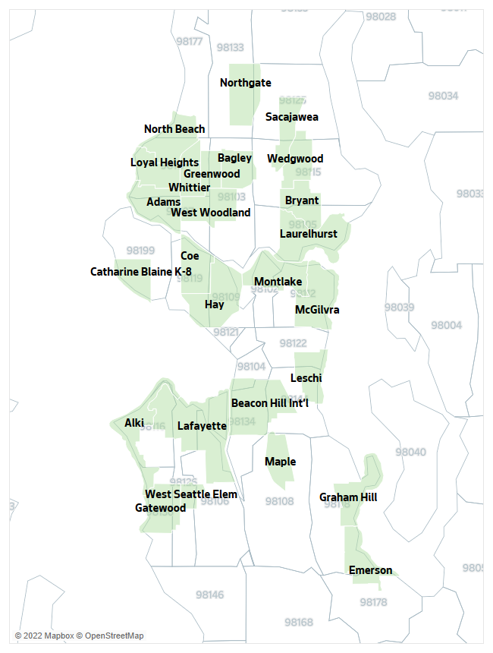
Top two Seattle Public School Equity Tiers, demonstrating population of children furthest from educational justice.
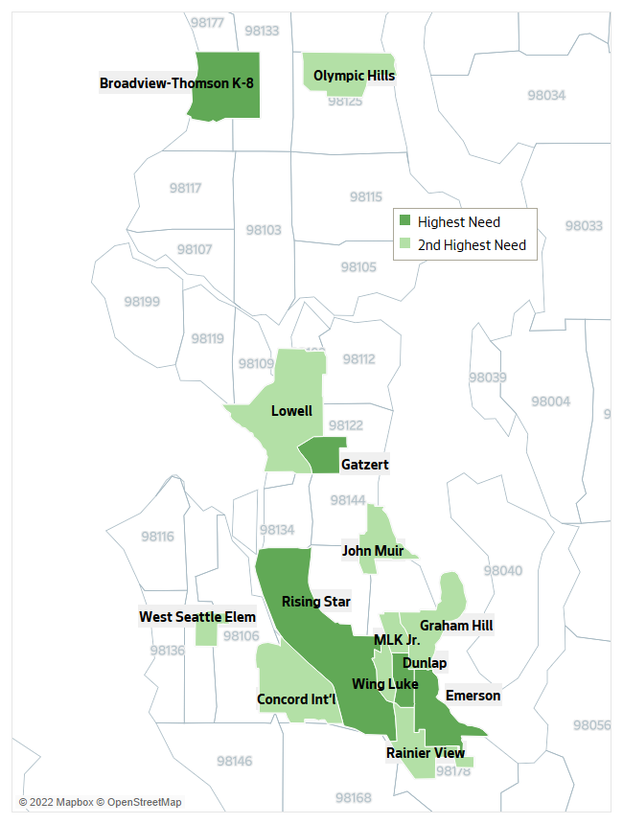
APPENDIX E: Benefits and Resources Available
Services in this RFQ are intended to supplement already existing classroom supports for SPP and SPP Pathway programs (See Appendix F for reference to Pathway). This appendix outlines the supports currently offered:

DEEL COACHING
To ensure high quality in SPP classrooms, DEEL Coaching employs a differentiated Culturally Responsive Instructional Coaching approach to provide intensive, intentional, and reflective coaching to classroom-based staff with a focus on race and social justice, anti-bias education, restorative healing practice and social and emotional learning.

All SPP teachers are offered monthly touchpoints with DEEL coaches. Sessions focus on continuous improvement of teaching practice and are based on cycles of observations, feedback, and goal-setting. In addition, coaches support educators by modeling high-quality teaching strategies, reflecting on data and assessments, and providing materials and resources. The quantity and focus of individual coaching support is differentiated based on teacher experience and self-efficacy, classroom-level assessments, and teacher goals.

DEEL’s child-centered, relationship-based coaching approach supports the processes of educator learning and the citywide achievement of positive academic, emotional, and social outcomes for children, educators, and families. Using four interconnected strategies: curriculum instruction, coaching, assessments, and training, this coaching approach supports family engagement, develops educator practices, is collaborative, and grounded in culturally responsive pedagogy (CRP).


Curriculum Instruction
DEEL coaches have in-depth knowledge of the curriculum (Creative Curriculum or HighScope) that is selected by the early learning agencies, as well as an understanding of diverse learning needs. To support teachers in implementing these curriculums with quality and fidelity, coaches model culturally responsive teaching and implement instructional reflective practice. Additionally, pre-service and in-service curriculum training support teachers’ knowledge of curriculum content.


Coaching
DEEL coaches use the lenses of equity and cultural responsiveness to understand the professional development and specific needs of each teacher, director, site supervisor, and preschool program. Using this approach, the coach draws upon and models diverse tools and strategies, including differentiated instruction and the ability to apply strength-based intervention strategies and supports. This tailored approach means that there is no fixed time frame or specific dosage for each participating classroom. Coaching activities focus on the person being coached, teacher-student interactions, collaborative partnerships, family engagement, and learning environments.


Assessment
DEEL coaches work in partnership with Child Care Aware, the Washington State Department of Children, Youth and Families (DCYF), Public Health — Seattle & King County (PHSKC), and the University of Washington to analyze data from the following identified assessment tools using a continuous quality improvement process:
- Ages & Stages Questionnaires (ASQ-3 and ASQ-SE)
- Classroom Assessment Scoring System (CLASS)
- Program Quality Assessment (PQA) (For classrooms using the HighScope curriculum)
- Teaching Strategies Gold (TSG)


Training
DEEL coaches play a pivotal role in supporting professional development. They assist in the following professional development activities:
- Director’s instructional leadership series
- In-service training
- Training Institutes
  - fall Pre-Service
  - spring “Children Race and Racism”
- Professional Learning Communities (PLCs)

PUBLIC HEALTH SEATTLE KING COUNTY
Child Care Health Program Description
The City of Seattle supports the Child Care Health Program (CCHP) of Public Health – Seattle & King County to provide an array of child care health consultation supports and services to childcare homes and early learning centers for children birth to 5 in Seattle that receive care in Department of Education and Early Learning subsidized programs. The goal of the CCHP’s consultation is to enhance opportunities for all children to receive from their providers healthy, safe, and life-enhancing nurturance, care, and guidance they need to develop, grow, and learn well.

The multidisciplinary array of services the CCHP provides to those programs includes:
- Public Health Nurse consultation around issues of child health, safety, and well-being to ensure programs are following best practices and meeting state regulations
- Mental Health Consultant assistance to help programs encourage positive child behavior, social and emotional development, and learning abilities
- Registered Dietitian consultation to ensure programs are providing children with healthy nutrition, food safety, and hygiene and sanitation
- And Community Health Professional consultation that supports the other three components of the CCHP’s endeavors as well as carries out its own body of work encompassing child health and wellness
- Conduct health and nutrition assessment, identify needs, outline health goals and provide technical assistance
- Provide health and nutrition consultations
- Annual infant room visit from PHSKC
- Annual visit to the infant and toddler classrooms for assessment, making recommendations and providing technical assistance and follow-up as needed
- Consultations monthly, using recommendations from initial assessment (Recommendations and technical assistance can change throughout course of year)
- Provide mental health consultations
- Provide oversight and technical assistance, as needed, to providers during child health screenings conducted by site personnel
- Review child health files
- Review child developmental screening results
- Provide health, mental health, and nutrition consultations
- Provide support and technical assistance services, as program standards require
- Provide oversight and technical assistance, as needed, to FCC Hub Agencies during child health screenings, child health files, reviewing development screening results and conducted by Hub Agencies, and delivering, as requested by the Hub, health, mental health, and nutrition consultations

Health Consultations. PHSKC will provide site-level consultation services for DEEL
partner agencies. Consultations should fit into one or more of the categories defined below:
Behavior Consultation
- Conduct child observations and work in collaboration with agency, family, and DEEL coach to develop individual plan for child.
- Implement or assist agency staff to implement Individual child plan.
- Provide additional services.
- Support agencies and families in navigating the Birth to Three or Child Find system as
- needed.
- Support families and providers in accessing behavioral and health systems as needed.
Health and Safety Nurse Consultations
- Provide goals and plans of support for care of children with special health care needs such as asthma, allergies, developmental and/or physical health needs, or other physical health concerns.
- Conduct child observations and work in collaboration with agency, family, and DEEL coach to develop individual plan for child.
- Review child health screening results.
- Support families and providers in accessing health systems as needed.
Nutrition Consultation
- Provide goals and plans for support by registered dietician to support children’s growth,
- nutrition best practices, and standards as required by ECEAP.

SPP Provider Facilities Fund
The Provider Facilities Fund supports preschool facility expansion and renovation projects for SPP or Pathway providers.

How can this support my work?
This fund is meant to support renovation and construction projects that will be used in SPP. Eligible activities include:
- Construction, renovation, or rehabilitation of child care facilities; including instructional space, kitchens, bathrooms, or storage needed to support the instructional space.
- Design, construction, renovation, or rehabilitation of outdoor play space in accordance with state licensing regulations.
- “Soft costs” or any project costs that is not construction (which may include design, project management, and permitting costs) directly related to the development of space eligible for use as a SPP classroom.
- Improvements that provide accessibility to persons with disabilities.

Who is eligible to apply?
Any agency under contract to provide preschool services for the Seattle Preschool Program (SPP) or the Pathway Program. Funds are awarded through a competitive application process. There are different funding limits for family child care, center, and school-based sites.

What will I be asked to include in the application?
Applications for funds need to demonstrate that the project is feasible and can be completed within a reasonable timeframe. Also, for the next five years, DEEL is focused on creating additional space for SPP where it is needed. You will be asked to show how the location you propose is a good strategic fit for SPP expansion.

Agencies accessing funds may be required to commit improved space to SPP for up to 10 years. The length of commitment will range depending on the funding request. Requests above $250,000 require a funding match and additional commitments from the providers.

How do I learn more and apply for funds?
DEEL anticipates that the Request for Investment (RFI) for the SPP Provider Facilities Fund will be released in 2023. All updated information will be posted here: http://www.seattle.gov/education/about-us/funding-opportunities

APPENDIX F: Pathway to SPP

If your organization does not currently meet the SPP eligibility requirements, you may be invited to initiate a contract for the SPP Pathway Program. During this time, the City will provide ongoing technical assistance, professional development and coaching to support Pathway providers in meeting the eligibility requirements for SPP. Your organization will be expected to work towards meeting full SPP eligibility requirements and apply to become an SPP provider for school year 2025-26.

Category | SPP Pathway Minimum Qualifications
Licensing | - Licensed by the Washington State Department of Child, Youth and Families (DCYF)  –or–  - Able to become licensed by DCYF within 6 months of contracting with the City for SPP Pathway  –or–  - Exempt from licensing because entity is a public school or institution of higher education
Early Achievers Rating | - Applicant must be enrolled in Early Achievers (EA)  –or–  - Must be able to enroll and begin participating in Early Achievers (EA) within 3 months of contract start date or within 3 months of becoming licensed
Documentation | - Copy of Applicant’s DCYF License (if available)  - Completed RFI Application  If unlicensed:  - Copy of Certificate of Occupancy or signed Lease Agreement  - If located in a Seattle Public Schools building, documentation of notification to SPS Alignment Coordinator; documentation can include email notification, letter, etc.

The following are preschool requirements for SPP Pathway:

# of classrooms | 1 or more
Classroom size | Not to exceed 20 children per classroom
Classroom demographics | - Minimum of 8 children in the classroom are participating in SPP Pathway
Child eligibility | - Seattle resident (lives within Seattle city limits)  - 3- or 4- years old by August 31, 2023
Student enrollment | Managed by Applicant: intake, eligibility determination, and enrollment
Teacher: student ratio | Not to exceed 1 teacher per 10 students (1:10)
Hours per day | Part-day (3.5 hours) or *full–day (6 hours)  - Must be able to become a full-day SPP eligible program within two years of contract start date.  - Full-day programs must be licensed*  Full-day (6 hours/day): The City will pay Applicants per child, based on two tiers determined by the applicant’s Early Achievers (EA) rating:  EA Levels 1-3: $10,311.83  EA Levels 4-5: $10,848.40  Part-day (3.5 hours/day): The City will pay the Applicant per child based on two tiers determined by the applicant’s Early Achievers (EA) rating:  EA Levels 1-3: $8,323.61  EA Levels 4-5: $8,856.84  Note: An Applicant who does not have an Early Achievers rating will automatically be paid at the Tier 1 level. The amounts reflected here are for SY22-23 and may change for SY 23-24.
Days per year | Part-day (140 days)  Full-day (180 days)
Curriculum | - Evidence-based curriculum

APPENDIX G: City Contracting Requirements

Successful applicants will enter into a contract for services with the City of Seattle and be required to submit the following documents at a to-be-determined date:
- Business license numbers. The contracting organization must meet all licensing requirements that apply to its organization. The contracting organization must license, report and pay revenue taxes for the Washington State Business License (UBI#) and Seattle Business License, if they are required by the laws of those jurisdictions.
  - Seattle business license number or copy of the license- Find information on applying for a COS business license here
  - WA State business license (UBI) number or copy of the license- Find information on applying for a Washington State business license here
- Recently signed W-9 form. The contracting organization must have a Federal Tax ID number/employer identification number (EIN) to facilitate payments from the City of Seattle to the provider. Link to form available here: https://www.irs.gov/pub/irs-pdf/fw9.pdf
- Insurance Coverage. As part of the contract, you or your agency will be required to carry the insurance coverage listed in the Contract Insurance Requirements Transmittal Form, located on DEEL’s Funding Webpage. We will need to collect the following insurance documents from you as proof of this coverage:
  - An Acord Certificate of Insurance
  - Additional Insured Endorsement or Blanket Policy Wording showing the City of Seattle as an additional insured
OR
  - Provide a certificate or letter of self-insurance
- Women or Minority Business Enterprise (WMBE)
  - If you haven’t already done so, we strongly encourage (but it is optional) that if you are a Women or Minority Business Enterprise, that you register in the City’s Online Business Directory (OBD). The City has made it a priority to contract with WMBEs and we use OBD for tracking purposes. You can find information on:
  - WMBEs: http://www.seattle.gov/city-purchasing-and-contracting/social-equity/wmbe
  - OBD: http://www.seattle.gov/city-purchasing-and-contracting/online-business-directory
  - And to register in OBD: https://web6.seattle.gov/FAS/OBD/Logon/Logon.aspx
    - Registering in the Online Business Directory will allow DEEL and other City departments to directly select you for contracting (vs. competitive solicitation) and to contract with you above some maximum thresholds without requiring competitive solicitation in the future regardless of WMBE status.
- Maintain the following insurance coverage, at a minimum:
  - STANDARD INSURANCE COVERAGES AND LIMITS OF LIABILITY REQUIRED:
 Commercial General Liability (CGL) or equivalent insurance including coverage for: Premises/Operations, Products/Completed Operations, Personal/Advertising Injury, Contractual, Stop Gap/Employers Liability (coverage may be provided under a separate policy), and Abuse and Molestation (ensure that it is shown on the ACORD Certificate of Liability Insurance Form or a confirmation email from insurance agent). Minimum limit of liability shall be
$ 1,000,000 each occurrence Combined Single Limit bodily injury and property damage (“CSL”)
$2,000,000 Products/Completed Operations Aggregate
$2,000,000 General Aggregate
$1,000,000 each accident/disease—policy limit/disease—each employee stop- gap/Employer’s Liability
  -  Automobile Liability insurance for owned, non-owned, leased or hired vehicles, as applicable, written on a form CA 00 01 or equivalent WITH MINIMUM LIMITS OF LIABILITY OF $1,000,000 CSL.
MSC-90 and CA 99 48 endorsements required unless In-transit Pollution coverage is covered under required Contractor’s Pollution Liability insurance.
  -  Worker's Compensation insurance for Washington State as required by Title 51 RCW.
- COVID-19 Vaccination Requirements for City Contractors: The Agency, at no expense to the City, shall comply with the Mayor’s Executive Order 2021-08: COVID-19 Vaccination Requirements for City Contractors - https://www.seattle.gov/purchasing-and-contracting/doing-business-with-the-city/covid-19-vaccination-requirements
- Maintain financial and program records, documents, and other evidence directly related to performance of the work in accordance with Generally Acceptable Accounting Procedures. The City of Seattle, or any of its duly authorized representatives, shall have access to such books, records and documents for inspection, audit, and copying for a period of six (6) years after completion of work.

Child Trends. (2018). High-quality preschool can support healthy development and learning. Retrieved from https://www.childtrends.org/wp-content/uploads/2018/05/PreschoolFadeOutFactSheet_ChildTrends_April2018.pdf
Hatcher, Beth; Nuner, Joyce; Paulsel, Jean. (2012). Kindergarten Readiness and Preschools: Teachers' and Parents' Beliefs within and across Programs. Early Childhood Research & Practice, v14 n2. Retrieved from https://eric.ed.gov/?id=EJ997132
Heckman Equation. Invest in early childhood development: Reduce deficits, strengthen the economy. Retrieved from https://heckmanequation.org/assets/2013/07/F_HeckmanDeficitPieceCUSTOM-Generic_052714-3-1.pdf
Muschkin, C. G., Ladd, H. F., & Dodge, K. A. (2015). Impact of North Carolina’s Early Childhood Initiatives on Special Education Placements in Third Grade. Educational Evaluation and Policy Analysis, 37(4), 478–500. Retrieved from https://doi.org/10.3102/0162373714559096

