How to download a form:
- Click on the form you want to download.
- In the upper right-hand corner, click on the “Download” icon arrow.


- Save the form to your drive.
- At the bottom left, you will see a drop-down box labeled with the name of the form you clicked on.
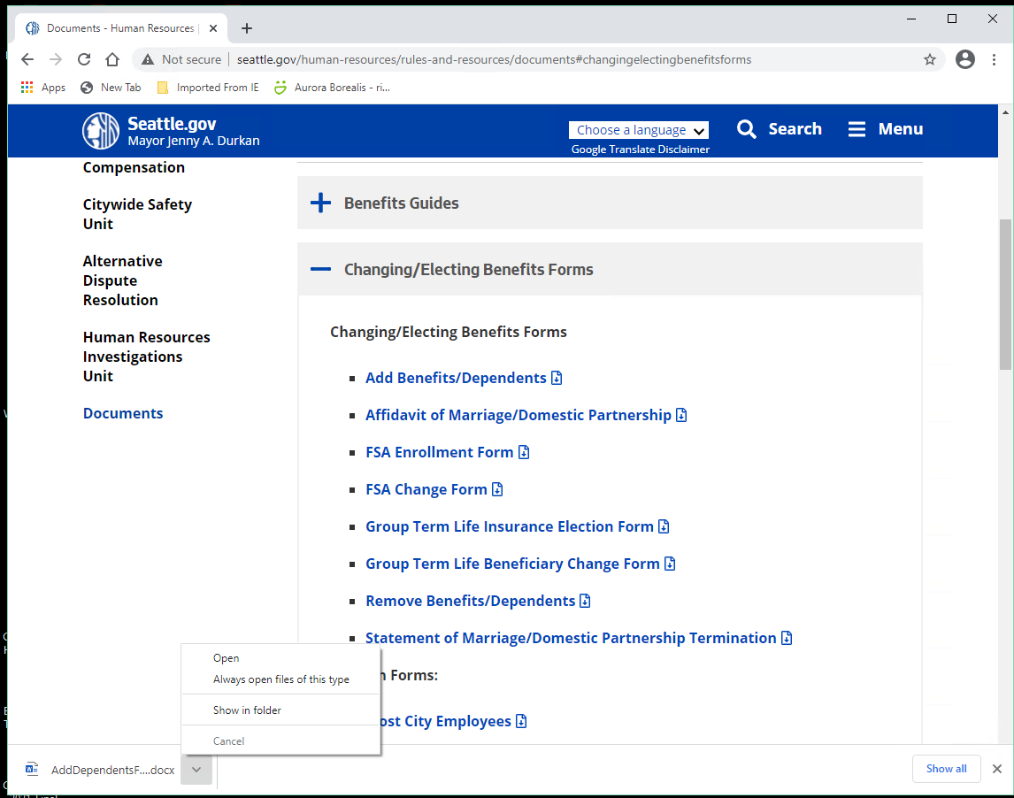
- Click on “Show in Folder” (so you’ll use the form you just saved in your drive).
- After you have filled out the form, save the document for your records.
- Send the document to your department’s benefits representative and copy yourself on the email to verify it was successfully sent.

